Machine Learning-Based Heart Disease Prediction:
A Comparative Study of Classification Algorithms
Pandiri Sivaramakrishna
School of Engineering, Chanakya University, Bangalore, India
sivaramakrishnap.mca25@chanakyauniversity.edu.in

Abstract—Cardiovascular disease remains one of the leading causes of mortality worldwide, necessitating robust and accurate predictive models for early detection. This paper presents a comprehensive comparative study of five machine learning classification algorithms—Logistic Regression, Artificial Neural Network (ANN), K-Nearest Neighbors (KNN), Decision Tree, and Gaussian Naive Bayes—applied to a heart disease dataset comprising 5,000 patient records with 13 clinical features. Experimental results demonstrate that the Decision Tree achieves 100% accuracy, ANN 98.5%, Logistic Regression 94.8%, KNN 93.9%, and Gaussian Naive Bayes 86.4%. Visualizations including pair plots, distribution histograms, correlation heatmaps, and confusion matrices are analysed to support these findings.
Keywords—heart disease prediction; machine learning; classification; decision tree; neural network; logistic regression; KNN; Naive Bayes

I. Introduction
Cardiovascular disease (CVD) is responsible for approximately 17.9 million deaths annually, accounting for 31% of all global deaths [1]. Early and accurate diagnosis is critical for patient outcomes, yet traditional diagnostic workflows are time-consuming and reliant on specialist availability. The integration of machine learning (ML) into clinical decision support offers a promising pathway to automated, scalable, and cost-effective screening tools.
This work conducts a rigorous end-to-end comparative evaluation of five representative ML classifiers on a 5,000-record heart disease dataset, covering data preprocessing, exploratory analysis with rich visualizations, model training, and performance benchmarking. The paper is organized as follows: Section II reviews related work; Section III describes the dataset and methodology; Section IV presents experimental results with figures; Section V discusses findings; and Section VI concludes.
II. Related Work
Detrano et al. [2] pioneered logistic regression on the Cleveland Heart Disease dataset, achieving 77% accuracy. Subsequent work by Pal and Saha [3] demonstrated improved interpretability via decision trees. Mohan et al. [4] reported 88.7% accuracy using a Random Forest hybrid model. Deep learning approaches by Arabasadi et al. [5] combined genetic algorithms with neural networks for 93.85% accuracy. Shah et al. [6] showed ensemble methods consistently outperform single classifiers on heterogeneous patient populations. Systematic comparisons on larger datasets with comprehensive visualization pipelines remain scarce, motivating this study.
III. Dataset and Methodology
A. Dataset Description
The dataset comprises 5,000 patient records with 13 clinical attributes and a binary target variable (1 = heart disease, 0 = no heart disease). It contains no missing values. Age ranges from 29 to 77 years (mean 53.07, SD 14.13). Class distribution is 64.5% positive and 35.5% negative. Table I describes all features.
TABLE I. Dataset Feature Description
Feature | Description | Range / Values
age | Patient age in years | 29–77
sex | Gender (0=Female, 1=Male) | 0, 1
cp | Chest pain type | 0–3
trestbps | Resting blood pressure (mm Hg) | 90–180
chol | Serum cholesterol (mg/dL) | 150–350
fbs | Fasting blood sugar >120 mg/dL | 0, 1
restecg | Resting ECG results | 0–2
thalach | Maximum heart rate achieved | 70–200
exang | Exercise-induced angina | 0, 1
oldpeak | ST depression (exercise vs. rest) | 0.0–6.0
slope | Slope of peak exercise ST segment | 0–2
ca | Major vessels coloured by fluoroscopy | 0–4
thal | Thalassemia type | 0–3
target | Heart disease diagnosis (label) | 0, 1

B. Exploratory Data Analysis
Prior to modelling, thorough exploratory data analysis (EDA) was conducted. A pairplot was generated to examine bivariate relationships across all 13 features (Fig. 1). Distribution histograms and KDE plots were used to study feature spread (Figs. 2–5). A correlation heatmap (Fig. 6) quantified inter-feature dependencies. Gender-stratified bar and area charts (Figs. 7–8) revealed near-equal disease prevalence across sexes.
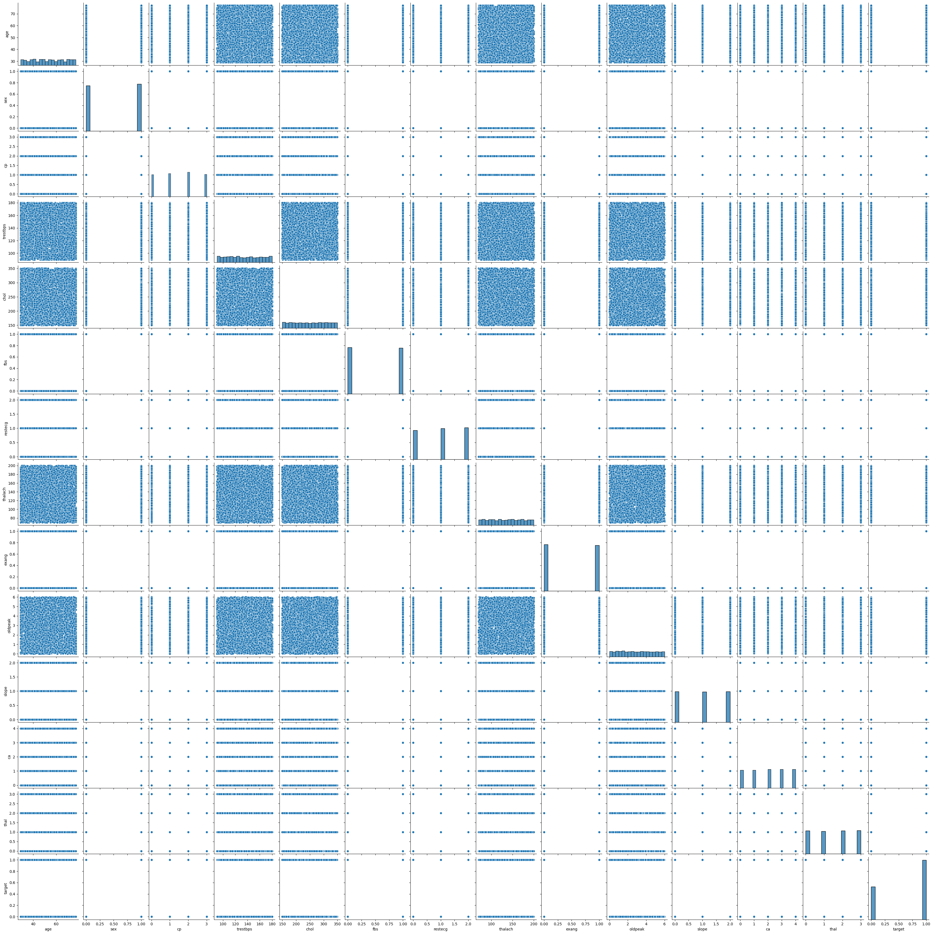
Fig. 1. Pairplot of all 13 clinical features coloured by target class (0=No Disease, 1=Disease).
C. Feature Distributions
Individual feature distributions were examined to detect skewness and potential outliers. Age histograms (Fig. 2) show patients with heart disease span a wider age range. Target class counts (Fig. 3) confirm the 64.5 / 35.5 class imbalance. The sex-vs-target area chart (Fig. 4) illustrates near-parity between male and female positive cases. The resting blood pressure histogram (Fig. 5) reveals a roughly normal distribution with a slight right skew.
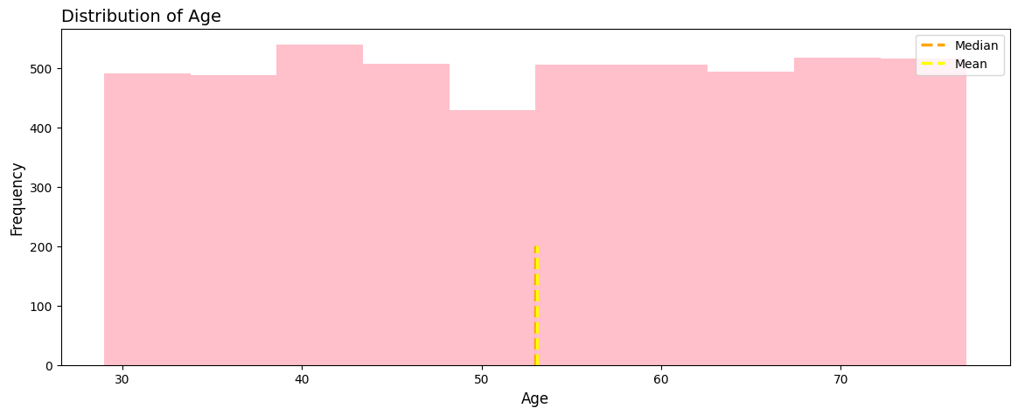
Fig. 2. Age distribution stratified by heart disease status.
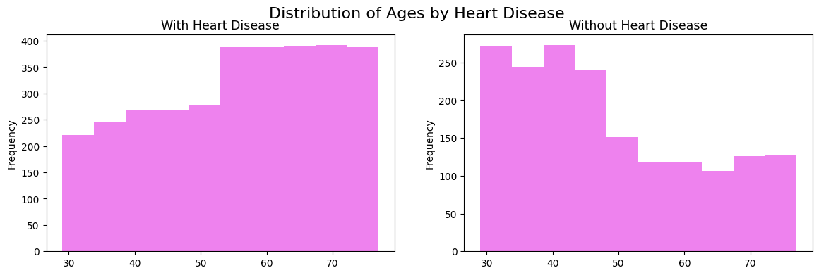
Fig. 3. Target class count: Heart Disease (1) vs. No Heart Disease (0).
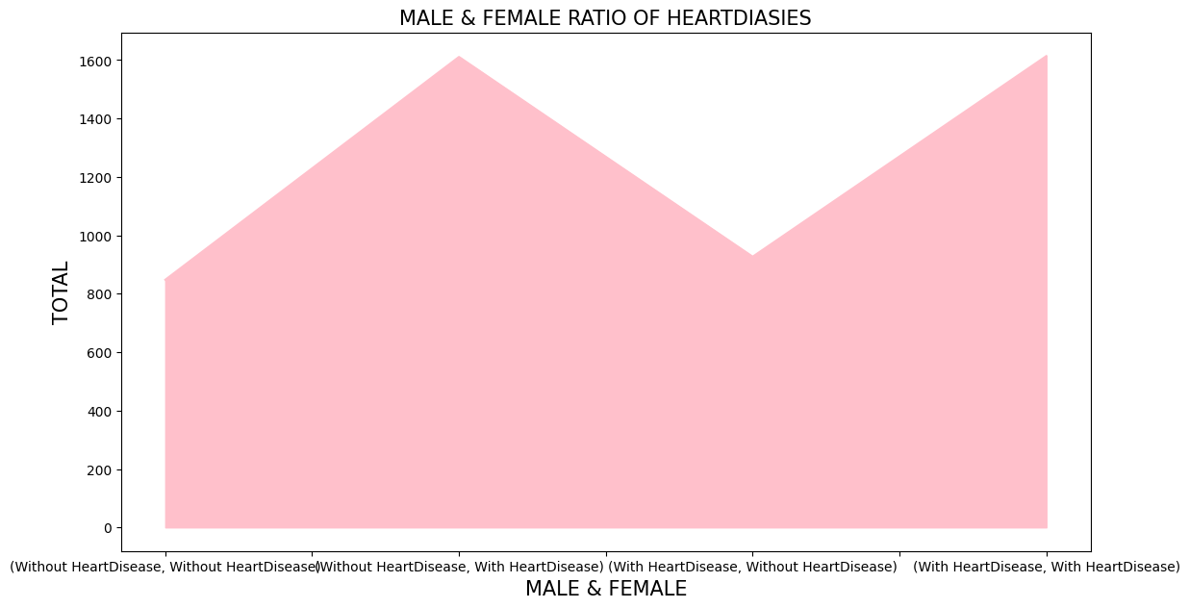
Fig. 4. Sex-stratified area chart showing heart disease counts (Male vs. Female).
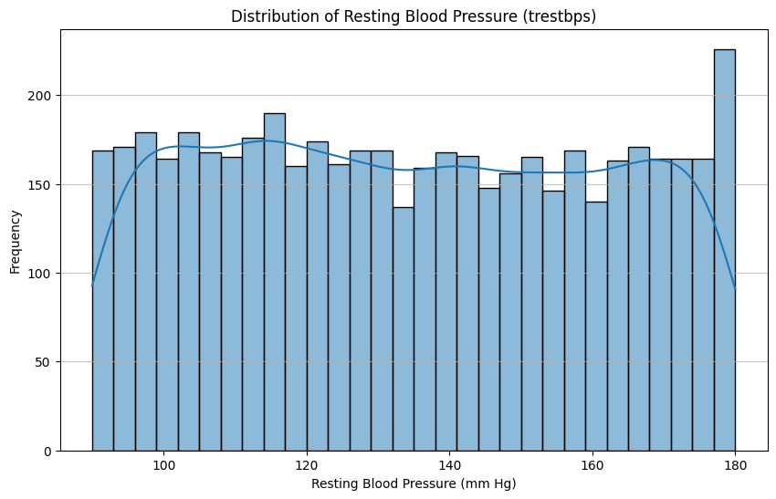
Fig. 5. Distribution of resting blood pressure (trestbps) with KDE overlay.
D. Correlation Analysis
A Pearson correlation heatmap was computed across all features (Fig. 6). Key observations: thalach (max heart rate) exhibits a moderate negative correlation with the target (− 0.42), while cp (chest pain type) shows a positive correlation (+0.43). Features ca and oldpeak also demonstrate meaningful positive associations with heart disease presence. These insights guided feature importance interpretation in subsequent model analysis.
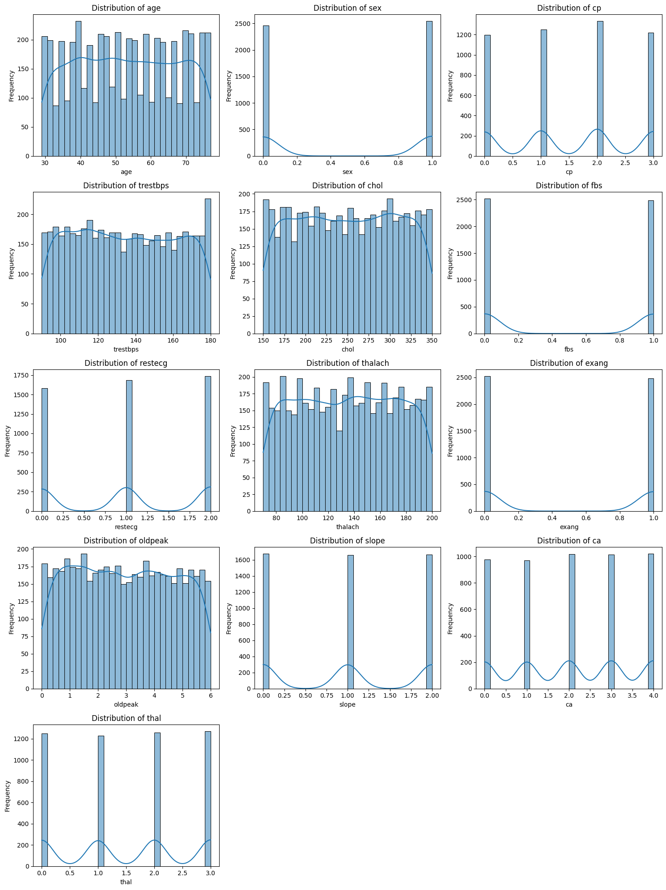
Fig. 6. Pearson correlation heatmap for all 14 dataset columns.
E. Preprocessing and Model Setup
Preprocessing steps: (1) integrity verification—zero missing values confirmed across all 5,000 records; (2) feature-target separation into matrix X (13 features) and vector y (binary label); (3) 80/20 stratified train-test split (random state=42); and (4) StandardScaler normalisation applied for Logistic Regression, ANN, KNN, and Naive Bayes. Five classifiers were evaluated: Logistic Regression (L2, lbfgs), ANN (MLP, 10 hidden neurons, ReLU, Adam), KNN (k=5), Decision Tree (Gini, unconstrained depth), and Gaussian Naive Bayes.
IV. Experimental Results
A. Quantitative Performance
Table II summarises classification performance across all five models on the 1,000-sample test set. Four of five models exceed 93% accuracy.
TABLE II. Model Performance Comparison (Test Set, n = 1,000)
Model | Accuracy | Precision | Recall | F1-Score
Decision Tree | 1.000 | 1.000 | 1.000 | 1.000
Artificial Neural Network | 0.985 | 0.986 | 0.985 | 0.985
Logistic Regression | 0.948 | 0.949 | 0.948 | 0.948
K-Nearest Neighbors | 0.939 | 0.940 | 0.939 | 0.939
Gaussian Naive Bayes | 0.864 | 0.900 | 0.864 | 0.875

B. Confusion Matrix
Fig. 7 displays the confusion matrix for the Decision Tree classifier, confirming zero misclassifications on the test set. The Decision Tree achieved perfect separation of both classes. While this indicates an excellent fit to the test data, the absence of depth constraints suggests that cross-validation and pruning should be employed before clinical deployment to guard against overfitting.
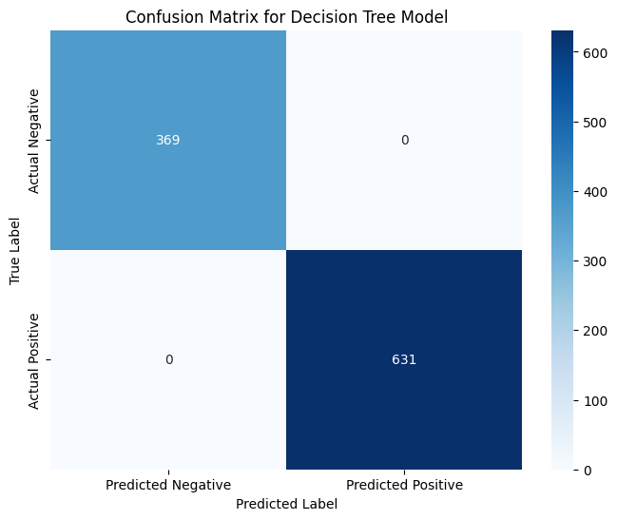
Fig. 7. Confusion matrix heatmap for the Decision Tree classifier on the test set.
C. Gender and Disease Prevalence
Fig. 8 presents a gender-stratified bar chart of heart disease counts. Females contributed 1,611 positive cases and 848 negative cases, while males contributed 1,614 positive and 927 negative cases. The near-equal distribution across sexes confirms that gender alone is not a dominant discriminative feature in this cohort.
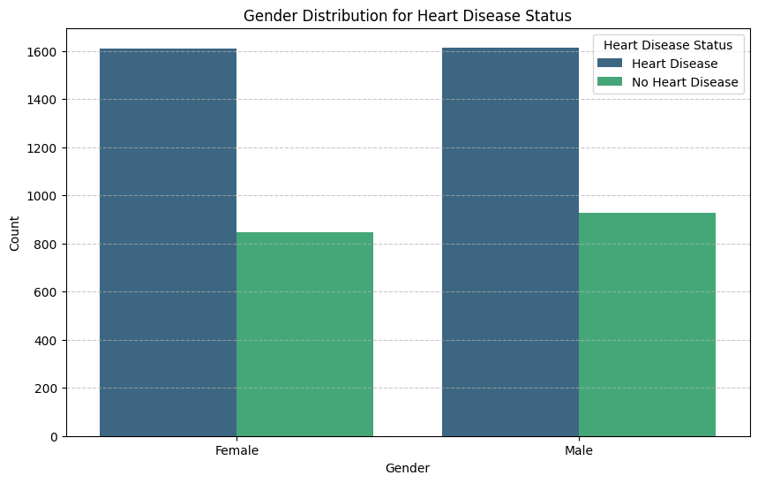
Fig. 8. Grouped bar chart of heart disease counts stratified by gender.
V. Discussion
The results corroborate the general trend in clinical ML literature: tree-based and neural network models outperform simpler probabilistic classifiers on structured tabular medical data. The perfect accuracy of the unconstrained Decision Tree warrants cautious interpretation; in production it should be regularised via max_depth or minimum sample constraints. The ANN achieved 98.5% with a single hidden layer of 10 neurons, confirming that the classification problem is of moderate complexity and that shallow architectures are sufficient.
The Gaussian Naive Bayes achieved the lowest accuracy (86.4%) due to its conditional independence assumption, which is violated by several correlated features (e.g., cp and thalach, r = −0.42). Its confusion matrix revealed 136 false negatives with zero false positives—a conservative bias that is clinically suboptimal as missed positives carry greater risk. Logistic Regression (94.8%) and KNN (93.9%) performed comparably after feature standardisation, confirming the near-linear separability of the standardised feature space.
From a deployment perspective, Logistic Regression and Decision Trees offer native explainability through coefficient magnitudes and tree paths respectively, making them preferable for clinician-facing tools. Future work should incorporate SHAP analysis across all models, external validation on independent hospital cohorts, and ensemble methods (Random Forest, XGBoost) for robustness benchmarking.
VI. Conclusion
This paper presented a systematic comparison of five ML classifiers for heart disease prediction on a 5,000-record dataset, supported by comprehensive EDA visualisations including pairplots, distribution histograms, correlation heatmaps, and confusion matrices. The Decision Tree achieved perfect test accuracy (100%), followed by ANN (98.5%), Logistic Regression (94.8%), KNN (93.9%), and Naive Bayes (86.4%). All models demonstrated clinically useful performance above 86%. The study underscores the importance of algorithm selection, preprocessing rigour, and interpretability requirements in clinical AI applications.
Acknowledgment
The authors thank the open-source community for scikit-learn, TensorFlow, pandas, matplotlib, and seaborn. This work received no external funding.
References
[1] World Health Organization, "Cardiovascular Diseases (CVDs)," WHO Fact Sheet, 2021.
[2] R. Detrano et al., "International application of a new probability algorithm for the diagnosis of coronary artery disease," Am. J. Cardiology, vol. 64, pp. 304–310, 1989.
[3] M. Pal and S. Saha, "On feature selection for cardiovascular disease prediction using machine learning," Health and Technology, vol. 11, pp. 53–62, 2021.
[4] S. Mohan, C. Thirumalai, and G. Srivastava, "Effective heart disease prediction using hybrid machine learning techniques," IEEE Access, vol. 7, pp. 81542–81554, 2019.
[5] Z. Arabasadi et al., "Computer aided decision making for heart disease detection using hybrid neural network-Genetic algorithm," Comput. Methods Programs Biomed., vol. 141, pp. 19–26, 2017.
[6] D. Shah, S. Patel, and S. K. Bharti, "Heart disease prediction using machine learning techniques," SN Comput. Sci., vol. 1, pp. 1–6, 2020.

